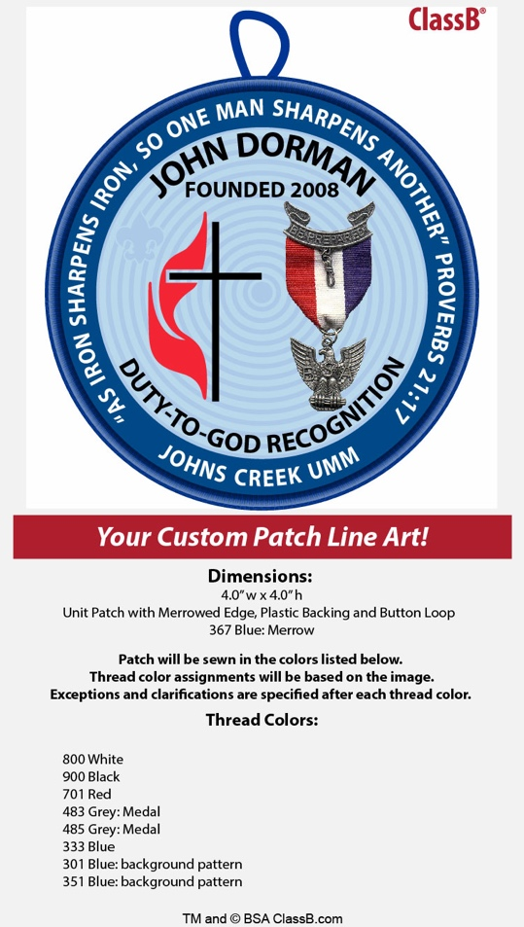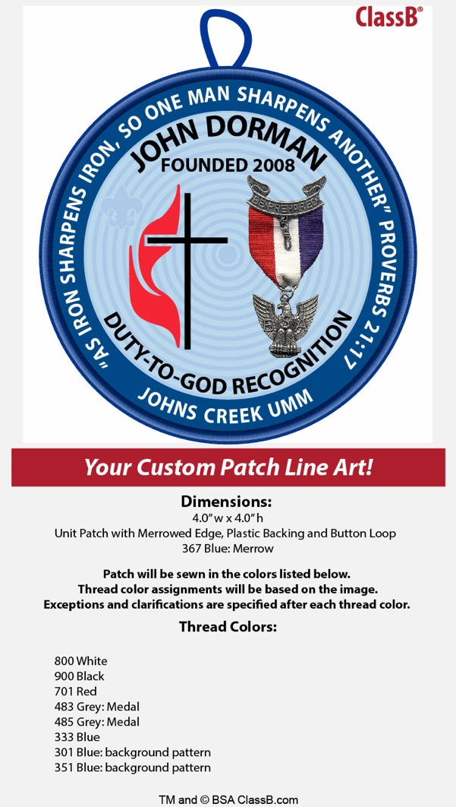

**John Dorman**

**Duty-to-God Award**

**2021 Nomination Form**

The Johns Creek UMM recognizes Eagle Scouts who go over and above exemplifying the character traits that John Dorman felt made the biggest impact on his life; Duty-to-God, Leadership and Service-to-others.

Requirements are that the Scout will have earned the Eagle Scout rank prior to nomination, is a Christian and has been nominated by an adult leader in his troop. Nominations should be made on this form and delivered to Dale Morton, Awards Breakfast Chair. (Note: Scouts may only be nominated one time). Nominations are accepted beginning December 1, 2020.

**Nomination Deadline**: Sunday, February 14, 2021 (5 pm)

**Submit to**: Dale Morton (dalemorton@comcast.net)

**Requirements**: - Eagle Scout (rank earned before this application is turned in)

- Is a Christian

- Readily exhibits Leadership and Service to others

- Nomination submitted by an adult Boy Scout leader, including

a statement attesting to the Scout’s character

**Questions**: Dale Morton (404-643-4043/dalemorton@comcast.net)

Scout’s Name: Troop #:

Scout’s Email: Phone:

Address:

School: Church:

Eagle Board of Review (date/ location):

Parent/ Guardian Name: Email:

Nominating Leader: Position:

Nominating Leader Email: ___________________ Phone:_____________________

Youth Minister, Pastor, Priest: _________________ Phone: ___________________

Youth Minister, Pastor, Priest email: _______________________________________

**John Dorman Duty-to-God**

**2021 Nomination Form**

**Nominating Leader:** Please review the areas below and provide examples that support the nominee’s candidacy. You may type up in a separate Word document as long as it’s presented in the same format, with the same questions and is the same length.

1. **Reverent** – please describe and/or provide examples of the scout’s spirit. What makes this young man a man in pursuit of God’s heart? How is he faithful in his religious duties?

2. **Leadership** – please describe this scout’s leadership qualities and offer specific examples of his leadership activities, experience, and characteristics.

3. **Community Service** – please describe how this scout has contributed to the betterment of his community.

4. **Friendship** – please describe how this young man has demonstrated his friendship to others.

5. **Scout Law** – please share examples of points of the Scout Law that this young man has demonstrated to others.

6. **Other** – What else would you like to tell us about this nominee?