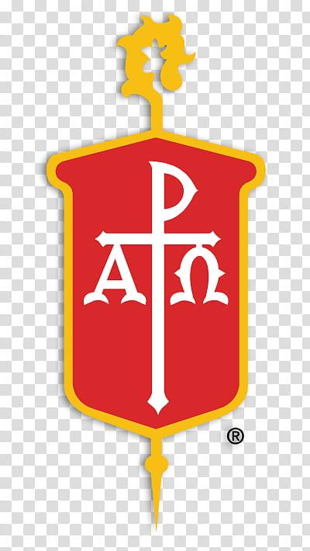
SHEPHERD’s GOLD AWARD

Purpose
To recognize churches which go above and beyond in their support of Boy Scouts and Girl Scouts. These churches welcome all youth and children; nurture them as they grow to become good citizens with a deeper relationship with God; and work with them in service to others.

Criteria
- Charter and host at least one each of 4 of 5 BSA and GSUSA programs. Includes one each of the following unit types:
  - Cub Scout Pack
  - BSA Boy Troop or Girl Troop
  - Venture Crew
  - GSUSA Troop
- PRAY: Promote and Conduct a PRAY program during the nomination year.
- Scout Sunday: Host a Boy Scout or Girl Scout Sunday service during the nomination year.
- Service Project: each unit conducts at least one service project during nomination year.
- Have an active Scout Coordinator managing the Scout program who has been BSA COR trained.

Nomination Process
The fulfillment of award requirements must be approved by the Pastor and Local Church Scouting Coordinator. Once requirements are met, complete and sign this application and send with a $10 check made out to UMC-NGA Conference to:

UMCOS (United Methodist Committee on Scouting)
Attn: Chris Karabinos (Conference Scout Coordinator)
1020 Fairway Estates NE, Brookhaven, GA. 30319

Questions: Chris Karabinos (770-490-4940/ chriskarabinos1@gmail.com)

SHEPHERD GOLD AWARD
Nomination Form

Church:
Street Address:
City/ State/ Zip:
UMC District:

List all Scout Units (either sponsored by the church or meeting on church property; for example BSA Cub Pack 123, Scouts BSA – Boy Troop 123, Crew 123 or GSUSA Troop 123)

PRAY Programs Conducted:
(program levels and finish dates)
Scout Sunday Date(s):
Service Project Date(s):
COR Trained Date:

Signatures
Scout Coordinator:
Email |  | Date
Pastor/ Minister:
Email |  | Date

Send completed application with a $10 check made out to UMC-NGA Conference to:
UMCOS (United Methodist Committee on Scouting)
Attn: Chris Karabinos (Conference Scout Coordinator)
1020 Fairway Estates NE, Brookhaven, GA. 30319

